水问题论坛——2024年第18回（总第450回）

报告题目：The changing role of groundwater in the global water cycle under climate change
报告时间：2024年10月25日 15:30-17:00
报告地点：地理资源所A901会议室
报告人：Prof./Dr. Yoshihide Wada
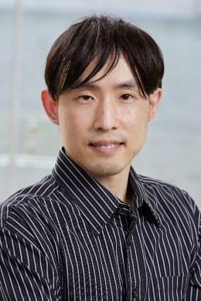
报告人简介：
Yoshihide Wada博士，阿卜杜拉国王科技大学（KAUST）教授、AGU会士、中国科学院PIFI国际杰出学者。研究兴趣包括生物圈（如水文、气候、生态系统、自然资源）和社会/经济方面的综合评估，使用系统科学方法来解决需要多学科/跨学科解决方案的交叉科学问题。他曾担任IIASA生物多样性和自然资源项目主任，参与领导了许多国际计划，包括欧洲GLOWASIS、ISIMIP、LandMIP、 EartH2Servate等。曾当选世界水理事会-世界水论坛WWC-WWF理事，荣获James B. Macelwane奖章。他撰写了约400篇出版物，其中300篇发表在包括Nature、Science、Nature子刊、PNAS在内的国际同行评审期刊，论文引用量每年超过8000篇（h-index：Scopus为90，Google Scholar为104）。

报告摘要：
Significant impacts of climate change and human activities have been observed on groundwater resources worldwide. These include changes in groundwater recharge, storage and distribution. Climate change has altered groundwater recharge rates, induced greater groundwater contribution to streamflow in glacierized catchments, and enhanced groundwater flow in permafrost areas. Human impacts on groundwater include groundwater pumping, regional flow modification, water table and storage alterations, and the redistribution of embedded groundwater in foods globally. Notably, (nonrenewable) groundwater extraction contributes to sea-level rise, which is still one of the largest sources of the uncertainty in global sea level budget. Groundwater’s role in the global water cycle is becoming more dynamic and complex. Quantifying these changes is essential to ensure availability of fresh groundwater resources for agriculture, industry, households and ecosystem functioning. This talk highlights the current status and future challenges in the changing role of groundwater in the global water cycle.

