水问题论坛---2023年第30回（总第427回）

报告题目：EPSRC funded flood risk research at the University of Leeds
报 告 人：Amrie Singh
时 间：2023年11月13日（星期一）上午10:00—11:30
地 点：地理资源所A901
报告人简介：
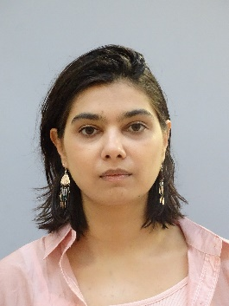
Amrie Singh is a research fellow in flood risk in the School of Civil Engineering at the University of Leeds. Her research includes urban flood modelling, coastal flood modelling, wastewater treatment, flood risk management and climate change. Her current research focuses on flood modelling in coastal cities. She has experience in multiple modelling programs such as HEC-RAS, TuFLOW, ICM Infoworks, Flood Modeller Pro, LISFLOOD, SWAT, Itzi, all used for flood risk modelling and assessment. She is on the Institute of Civil Engineers (ICE) flooding community advisory board, and also a member of the chartered institute of water and environmental management. Amrie also has 2 years consultancy experience as a flood modeller (River and coastal) in the UK, she recently gained her certification in ECBA for business analysis to improve her position in consultancy. Recently Amrie was awarded the EPSRC Post-doctoral fellowship grant to investigate compound flood risk in Kerela, India. The project focuses on understanding multiple sources of flooding and the impact of nature-based solutions on flood risk. The Engineering and Physical Sciences Research Council (EPSRC) is the main funding body for sciences and research in the UK which invests advancing knowledge, and deliver sustainable and resilient UK, the council dates back to 1965.
报告内容摘要：
This presentation provides a synopsis of two research project focused on flood risk undertaken at the University of Leeds. The first project focused on utilising flood models, namely Tuflow and HEC-RAS to identify flood source areas (FSAs) in a catchment. The methodology involved representation of sub-surface drainage and climate change scenarios to assess their impacts on FSA identification. The results demonstrated that both drainage representation and climate change influence the identification of the areas that contribute to significant flood risk. Building on the findings of the first project, EPSRC funded a postdoctoral fellowship which centres around compound flood modelling and the exploration of nature-based solutions in Kerala. This project simas to develop a comprehensive understanding of compound flood modelling which occurs when multiple flood drivers coincide and explore the sustainable and nature-based solutions to mitigate the impacts of flood risk within the region.

